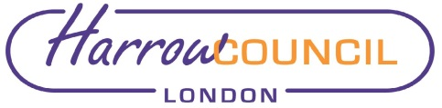

REPORT FOR: | Corporate Parenting Panel
Date of Meeting: | 11 June 2019
Subject: | Harrow Children Looked After Health (CLA) Report
Key Decision: | No
Responsible Officer: | Zoe Sargent, Associate Director of Children’s Services, Central & North West London
Portfolio Holder: | Councillor Christine Robson, Portfolio Holder for Young People and Schools
Exempt: | No
Decision subject to Call-in: | No
Wards affected: | All
Enclosures: | Children Looked After Health Report

Section 1 – Summary and Recommendations

This report reviews performance indicators and the delivery of health services to Harrow’s Children Looked After (CLA) during March – April 2019 in line with national guidance.

Recommendations: That the report be noted

Reason for recommendation: To keep the Panel informed of the clinical work undertaken by the Children Looked After Team.

Section 2 – Report

See attached report

Options considered
Not applicable as this is an external information report.

Ward Councillors’ comments
Not applicable as it affects all wards

Risk Management Implications
Not applicable as this is an external information report.

Legal Implications
Not applicable as this is an external information report.

Financial Implications

Not applicable as this is an external information report.

Equalities implications / Public Sector Equality Duty
Not applicable as this is an external information report

Council Priorities
The report focuses on:
- Supporting those most in need
- Protecting vital public services

Specific focus is on the service delivery from health to Children Looked After:
- Children and young people are given the opportunities to have the best start in life and families can thrive
- Healthcare services meet the needs of Harrow residents

Section 3 - Statutory Officer Clearance
Not applicable as this is an external information report

Ward Councillors notified: | NO, as it impacts on all Wards
EqIA carried out:  EqIA cleared by: | NO  N/A – external report

Section 4 - Contact Details and Background Papers

Contact: Emma Hedley, Named Nurse for Children Looked After Harrow,
Tel: 01895 484945, Email: emmahedley@nhs.net.

Background Papers:

Corporate Parenting Panel Reports
October 2018, January 2019, March 2019

